**Internal user testing**

**Ari:**

Onboarding:

* If we want users to read the data usage section, separate screen would be ideal.
* In between screens for starred locations

Home screen:

* What is to log? Is there a input bar? Disconnection from ready to log and address bar.

Documentation:

* Clicking the check mark? Can I still move on?
* 4th step of documentation: looks like a home screen. Dont know why it is asking for the route(?)

Emotion map:

* Funny representation of traffics

Inbox:

* ..

Archive:

**Kate C:**

Pre-lim Qs

* Yes, full time student. She walks to and from school. Working on an animation project outside of school, is a graphic designer for cmu, goes home sometimes for dinner (but not recently). Recently not much outside of school.
* ~15 (low estimate)
* Uses the transit app (but does not contribute to any)
* Transit app (hitting “go”)
* Messenger (easy for communication), procreate for tablet, instagram
  1. Good because a lot of people use them

Home screen:

* First reads the text
* Thought grocery store was current location
* Knows we’re logging travel
* You can save different routes you use to get places (?) from profile screen
* Is very confused through the logging screens
* Thinks you’re mapping what travel routes you take and how you get to places
  + Maybe you share routes so people can know which is fastest, which has scenic views
* Thought you type in where you want to go

Onboarding:

* Slight confused to pinpoint your whole area
* Thought starred locations were places along your route
* Was confused that there was a grocery store between the home and office
* Immediately clicked on “sign up”
* Was surprised it was a “social media thing”
* Was surprised about the researcher part
* Didn’t read data usage part

Task 1

* Figured the colors represented heaviness of traffic
* “There’s a lot of angry people” - after zooming in
* Can’t tell the difference between the meaning of the emojis mean
  + What is the different levels of negative?

Task 2

* First clicked on the journal
* Then went to inbox, follow up from
* Was confused on what specific information you get to log
* Knew there’s messages… about logging things?
  + Was confused on tips to improve logs by isadora’s fake message
* Was confused on the amount you log
  + Is it just amount of transport you use
* Unconfidently felt like the inbox was messages from other participants + researchers, and other one is her logs
* Inbox looks kinda like messenger, also looks kinda like people logging things
* Icon next to someone’s name in other apps
* Is it like email

Task 3

* Successfully clicked on log
* Was surprised there were comments there too
* Would click on edit icon

Task 4

* Go to home screen?
* Went to profile
  + Then would add there

Other thoughts

* A lot of confusion going in blind
  + Didn’t realize it was a data collection app
  + Would feel more comfortable if had known it was for research

**Aldy L:**

Pre-lim Qs

* Yes, full time student. Outside of school he plays games, naps, and painting (for non-assignments).
* Unsure for amount of hours, since he’s has the music app open while he works (for ~8 hours). Actively on the phone ~2 hours a day (14 / week).
* ~1 hour a day of walking
* No active transit data logging
* Tried Strava in high school -- it was a combo of route tracking + speedometer. Popular for cycling. Felt he didn’t have the right setup (didn’t have phone mount on bike), since he used it to get a sense of speed + where to go rather than using it for training like others did.
  1. Heard that the routine route data could contribute to people getting mugged
* Favorite apps: music app (since he like using to music), google maps (most game changing), youtube (favorite source of entertainment), instagram + twitter
  1. Likes youtube ui, when you click on home button on android, the video minimizes and continues in the bottom corner

Home screen:

* First notices map, then immediately reads text
* Doesn’t understand what “logging” means
  + What kind of situation do you need to log in?
  + Assumes you would know what that means if you downloaded the app
* Assumes the top marker is his current location
  + It’s the biggest, reminiscent of google maps
* Sees star as a favorited place
* Sees bottom right as globe or world
* Far right looks like first page of a notebook? Strange it’s the first page. Or a slider?
* Wants to be able to move map
* Was confused about what “log here” means
  + Didn’t think that’s where he currently is (since he thought the other marker was his current location)

Logging:

* Wouldn’t have noticed that you could swipe to the next screen in the logging area
  + Thought instagram has an arrow for the next screen
* Was confused why emoji page was on it’s own
* Normally you can add emojis to picture
* Logging is in past tense, so he’s assuming it’s the transport he used to get to where he is now
* Is confused how logging works -- normally he would think it’s after the fact
  + Thinks he’s searching the destination
  + Assumes where you’re going has to be kind of specific so you can search on the map
* Didn’t realize you could scroll because dots were in the way
* Was surprised by “where are you coming from”

Onboarding:

* Doesn’t like the word “emotional” data
  + Sounds like it’s supposed to help the user out on a bad day
  + Doesn’t sound professional (vs qualitative / quantitative
* Is confused why sign in / sign up is there
  + Is concerned that the buttons might be gone if he swipes
  + If it were a scroll he’d have less anxiety about it disappearing
* Didn’t read any text
* Felt concerned pinpointing his workplace
* Felt that the grocery store / bank / school was scary

Task 1

* World makes him think of globe, so he presses that
* Imagined it would be like google earth, zoomed out
  + Didn’t think it would show other people’s routes
  + Doesn’t think about viewing people’s routes on a globe
* It looks like an map showing magnitude / epicenter of earthquakes
* Doesn’t like the shadow on the ground pin-- makes the perspective really weird
* Wonders what one unit is
* Noticed yellow/green after a few minutes
* Assumes the circles with red lines are people’s data
* Notes lots of angry people + someone sad when it zooms in

Task 2

* Clicked on inbox
* Notes the messages he has / hasn’t opened
* Inbox doesn’t look very traditional, but is still very clear

Task 3

* Goes to notebook icon
  + Didn’t think the icon was super clear, since it doesn’t have text on both sides of page or curvature of book
* Doesn’t know how to change time added

Task 4

* Assumes you hold down for video

Task 5

* Went to account to change starred locations

Other thoughts

Xavier A.

→ Yes, extracurriculars

→ 28x hours a week

→ Not transit data, but sometimes I track walking distances for calorie tracking

→ I have an app that gives you money for walking a lot

→ sweatcoin

→ use to buy things in app

→ Yeah, actually maybe not - well is the google stuff crowdsourcing? Not research…

→ I use instagram + snapchat a lot, and messaging apps - I use soundcloud as well for music. PAtrack is one of the most functional, use it everyday to track the bus

___

Onboarding section

→ very sleek, hard to go back

→ straightforward

→ seems transit related - frustrations and traffic, traffic jams and crowdsourcing information about traffic

→ anonymous too (which is nice but idk if I can trust bc of a lot of companies say this and lie about that)

→ Seemed confused about transition from profile to map

→ recognized what to do ]

→ don’t know difference initially between starred location

→ for making trips

→ starred locations seem like stops along the way

→ changes to “ahh you can switch between locations”

___

→ I wish there was an indicator of where I was on the map at all times…

→ I wish I could slide between doc screens

//for logging data

→ confused about last documentation portion

//indicator of where you are at all times

→ make start + end colors different, too

Confusing now

archive

Setting up trips, or previous trips?

→ looks like previous trips

//I want to close it (keeps tapping the thing on the archive screen)

→ I like the map

I logged my data in-between

→ if logging maybe it should just be the emoji I put down

messages

→ maybe I have a convo w/ people telling me how to improve

Settings

→ you can update info

→ see starred locations

Emotion Map

→ This feels like how people are feeling and makes me feel cautious of the mad red + yellow areas

→ want to avoid

→ I wonder whether people are spamming but maybe not bc you have to fill out a whole report

__

→ got it right

I wish I could just slide over from the main map - but maybe- not?

→ got it right

→ “go to journal thing, press trip you made”

→ this is a little confusing

→ press day, go in, yep

Last task

→ I would try to press on map, set through there

→ I would try to press on map w/ones there and delete

But I guess you can in settings too

Thomas Y.

yes, youtube.

3 hours a week maybe, I don’t use mobile apps

2 hrs on bus a week maybe, but I mostly walk about 40 minutes everyday - probably more than that but yeah at least 40 minutes everyday

I never have

No

YouTube - it’s very much smoother than the web version on mobile and the screen takes up the entire screen whereas on a browser there’s a bar which is really annoying

**On-boarding page tour**

* so you’re sharing photos and videos and you get to see where and when it was submitted - I guess you can respond to it somehow? That’s what the fb emoji makes me think
* Okay so I guess I work in santa cruz, okay

**HOMEPAGE**

* Okay so I took a photo and I want to log at jollibee
* oh no! I take the photo through the app, I see
* and I can edit it if I want to so but it won’t let me
* I take another clearly unpaid stock image photo
* Yeah I mean well this is pretty intuitive, I like it
* How do I go to the next stage though
* And I can add an emoji, but that confuses me - I don’t understand why
* Okay so I’m in a traffic jam and I’m clearly mad so I’m gonna press some emojis I guess
* For documentation: I don’t know if I would want to write short answer when I’m uploading photos - maybe you could have just one text box at the very end for people to write one paragraph or something
* If I were a Manila citizen, I wouldn’t want to spend time to write this thing down (doesn’t realize you can save and come back to later)
* Make it clearer that you can upload from your phone
* It’s confusing because say you took a photo from Manila and it asks you where you started and where are you going - so change the language of the question or in my opinion the order has to be reversed altogether - the logging and submitting should be done with it ; once you click the submit button you should be done with it! - maybe asking for the whole route they took is an optional question

**Task 1**

* I would zoom in on the home map and expect to see in the way that you would zoom in on google maps and more stuff pops up
* I don’t know that any of the icons on the bottom would tell me
* OH I see, the globe icon
* I really think you should merge this to the home screen, I don’t think you need two maps - I think you just need one map - when I look at that globe icon I don’t think of other people’s submissions I think of a network

**Task 2**

* Yep, would go on the mail button and click on the message
* pretty straightforward

**Task 3**

* looks lost
* Uhhhhhhh shit
* umm
* hmm
* I guess I expected to see my own post on the home screen map
* If you have the location and you click on it you can view all the logs you made previous for that location
* On the archive you can only see the date and the time and not location whereas if you told it by location that seems a bit more intuitive to me
* Okay I can do whatever I want - I like the interface, very intuitive, but I wonder if it can be integrated into the home screen; maybe you can have a bigger icon for a place you logged multiple times and a smaller icon for something else

**Task 4**

* Okay I would just hold the photo button, everyone is used to that
* and then note
* pretty straightforward but I still really don’t understand the route portion

**Task 5**

* I would click on the star in the home page (intuitive)
* Or go to settings and edit or delete or add in the account info tab

**Yoon Young Kim**

Pre-lim questions:

1. Full-time student. Is heavily involved in sorority life, especially in participating in philanthropy events.
2. Uses apps about 70 hours a week.
3. Travels on transit 2 to 3 hours a week, bus; walks about 3 hours per week.
4. Not have used an app like this before.
5. Has not contributed to a crowdsourcing app.
6. Favorite app is MyFitnessPal.

Homescreen

* Paid attention to the search bar first.
* Favorite pin (with star) was notable -- thought that that was the current location.
* Thought the amount of pins populating the board was a little too much visually.
  + Suggested to downplay the other pins on the screen -- maybe just make them into dots that have a description pop-up when tapped on. (people will quickly learn these locations at that scale of the map).
* Confusion with the logging XD; flow through the home screen to get to that point makes sense but the actual logging experience needs more dialogue
  + Robert: might be because of showing homescreen first before onboarding.
* Would like a “primary emotion” feature -- an individual entry that can sum up how a person is feeling.

Onboarding

* Read through onboarding screens. Skipped through terms of usage and data
* Tapped sign-up after reading through.
* Understood the point of favorited places, and how they were highlighted around the map screen.

Task 1.

* Tapped on the globe icon.
* Read colors as emotional content
* Doesn’t really understand correlation between the variation of emojis and limited color range.

Task 2

* Tapped on mail icon.
* Thought that that was it, before moving onto the archive icon
* Found researcher feedback, but was confused as to how to respond. (no option to respond via archive section.)
  + Suggested that there could be a link in the researcher feedback section to “send an email” to the researcher.

Task 3

* Went to the archive.
* Tried to tap on the time, but that just led to the expansion of the log.
* “There should be an edit button for time too”

Task 4

* Entered into the logging phase after tapping onto their locations.
* Pretended to take video, skipped emojis, pretended to write note in “what i did today” section.

Task 5

* Went to profile page
* Would tap on commute information.

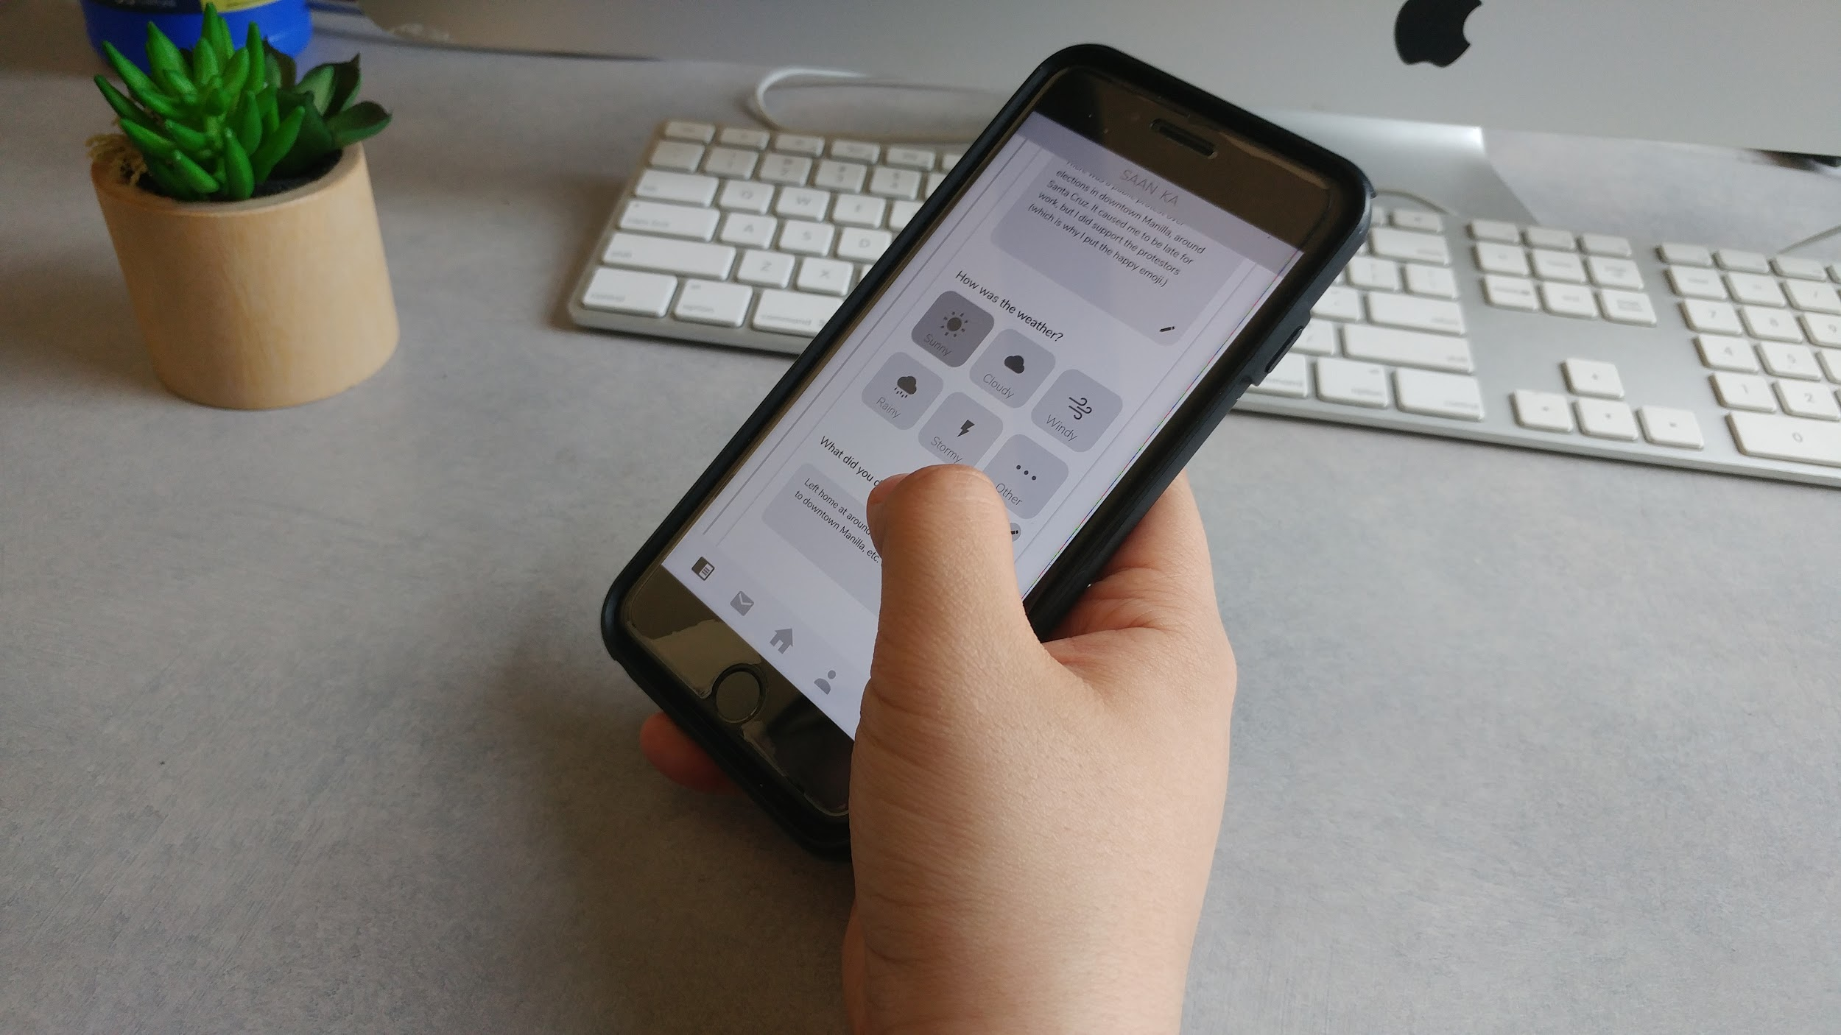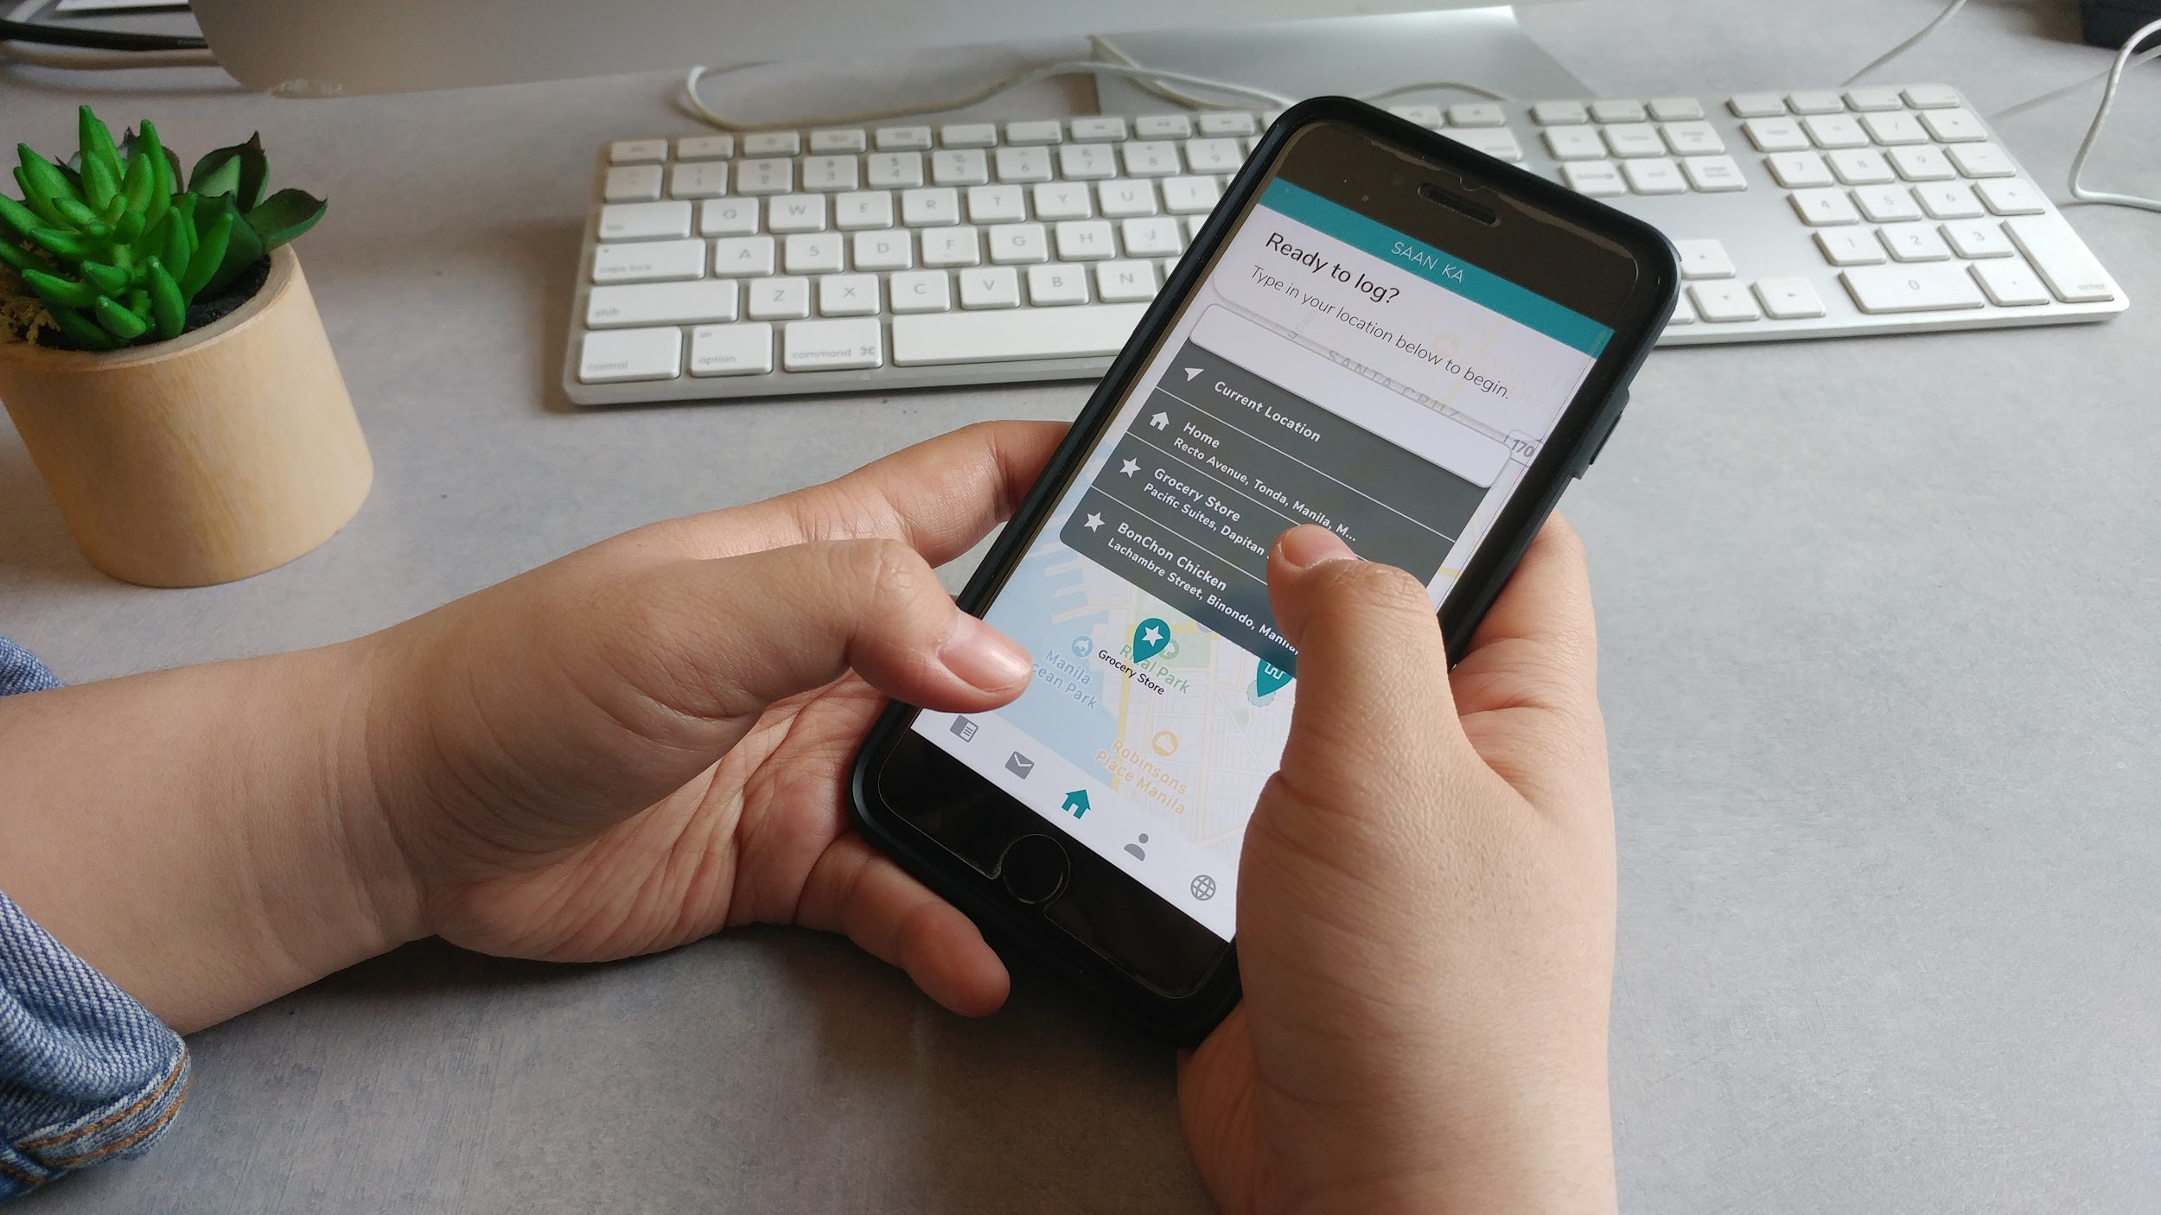

**Rachel Kim**

Preliminary Questions

1. Full time student, no major outside commitments
2. About 80 hours per week on phone.
3. About 3 hours in bus transit; walks about 3.5 hours
4. Has not used logging app
5. Does Spotify public playlists count?
6. Messenger

Onboarding/Homepage

* Tapped on sign-up after reading through each screen.
* “So it’s like a journaling app?”
* Did not read data collection/terms of condition.
* Tapping home/workplace/favorite locations made sense.
* Went for the search bar first on home screen. Able to get to log screen
* Initially confused by logging screen.
  + Suggested that there could be a one-time pop-up for first-timers “Hi there! Since it’s your first time here, we wanted to show you around.”
* Thought the swipe through was confusing. Why not just have a checkbox-like menu of the different ways of logging they can do, and also have the submit on that same screen?
  + Suggested dialogue like “While we’d like to have as much information as possible, feel free to log what information you can. We’ll get in touch if we need more”

Task 1

* Tapped on globe icon.
* Thought colors correlated to traffic patterns.
  + “You don’t typically associate emotions to colors especially on a map. Usually it means a street is congested”
* Thought the close-up view was really interesting. Tried to tap on the individual icons to see if there was any additional information.

Task 2

* Went to inbox first. Found mail.
* Went to archive and successfully interacted with accordian expansion. Found research feedback section.
* Thought archive was neatly organized. Photos could use a better visual “container”

Task 3

* Went to archive immediately.
* Tried to tap on time, but that led to expansion.
* “Should have edit icon here”

Task 4

* Went to logging UX.
* Logged same as task 0.

Task 5

* Went to profile section

**JP**

1. Yes, dating, frat life, soccer, and gym
2. 15 hours a week
3. Under an hour –bus uber
4. No
5. Yes – multicultural study, It felt good because I was contributing to the society
6. Safari for looking up things that I am interested in such as sports scores, instagram to keep up with what is going on in pop culture and keeping up with old acquaintances, Spotify for listening to music

Tour:

* Don't understand the language of the title —> Indonesian takeout food
* Buttons don't seem to work
* Seems like a social media platform for sharing emotional and logistical information on shared routes
* Unresponsive because all buttons dont work
* Don't recognize the app just by using it. I feel like someone should explain it to me
* I'd rather use some other existing application for the emotion map
* Lack Visual communication —> unclear what I’m supposed to do (almost like guess and check)

Task 1:

* World map view
* Red = most / concentrated activity

Tasks2:

* Click on the mail icon for messages
* And I would click on specific messages but I cannot click or respond in this prototype

Task 3:

* Clicked on profile, but it wasn’t
* Through process of elimination
* Found the archive icon
* tried to scroll a lot
* Pencil icon helped me find out that I can edit the info

Task 4:

* Home is defaulted to logging
* feels find of like a chore because the process is way to long
* I would press the home button instead of the exit button

Task 5:

* Route information?
* Hard to find —>maybe put it on the homepage